Conley, Tom Office Hours: in the Kirkland
Romance Languages and Visual/Environmental Studies Dining Hall (anytime)
Kirkland House, 85 Dunster St. 617-493-8220 or 617-495-2274
Harvard University tconley@fas.harvard.edu

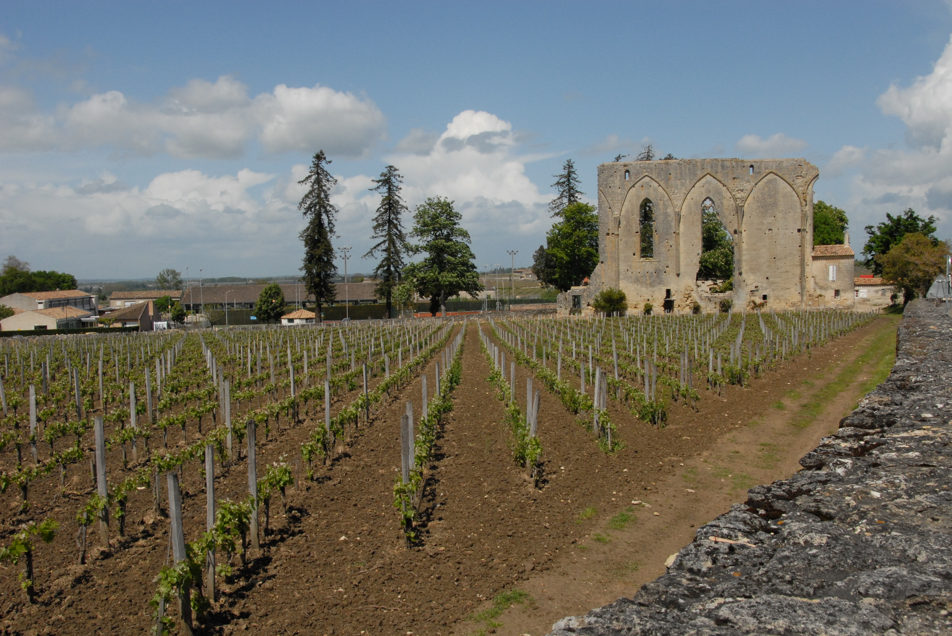

Saint-Emilion (May 1, 2008)

Oenography : Topologies of Wine

Goals :

This class can be understood as an apprenticeship in the savor of knowledge. In the early modern age savoir denoted both « knowledge » and « know-how ». It included in its gamut of meanings saveur, that includes both a sense of things and the « nose » of he or she who « knows how to know». To know meant knowing the craft of living well: about smelling, tasting, and blend the keenest and even fleeting and no less vital sensory impressions with the labor of thinking and doing. It meant, too, the sensual art of everyday life, a conscientious deployment of generous energy, in which are included savor of sharing and comparing taste of the world and its languages. In this realm wine and food play crucial roles. It would be beyond the bounds of a semester to study at once oenology (the science of wine) and gastronomy. Nonetheless we would like to dwell on the former with an eye cast on the latter: for without wine, as the French goes, the day is without sunshine : journée sans vin, journée sans soleil. In view of the savor of knowledge we take the goal of this class to be an apprenticeship in the art of knowledge in the best of all senses.

Means:

Since wines are given to the places in which grapes are grown we shall study the geographies of the wines of the world. If we recall that Michel de Certeau designates a space to be a « place practiced », that is, riddled with experience and language of those who live and move about it, we shall turn the « places » known by their wines into the « spaces » of experience of our own. To do so we can begin by studying the wines and regions of France, the locus classicus and the standard against which all the wines of the world are judged, according to its grapes and its places. From there we shall move to Italy and Spain ; to the New World, to California and Latin America ; and then south and to the east, to South Africa and Australia.

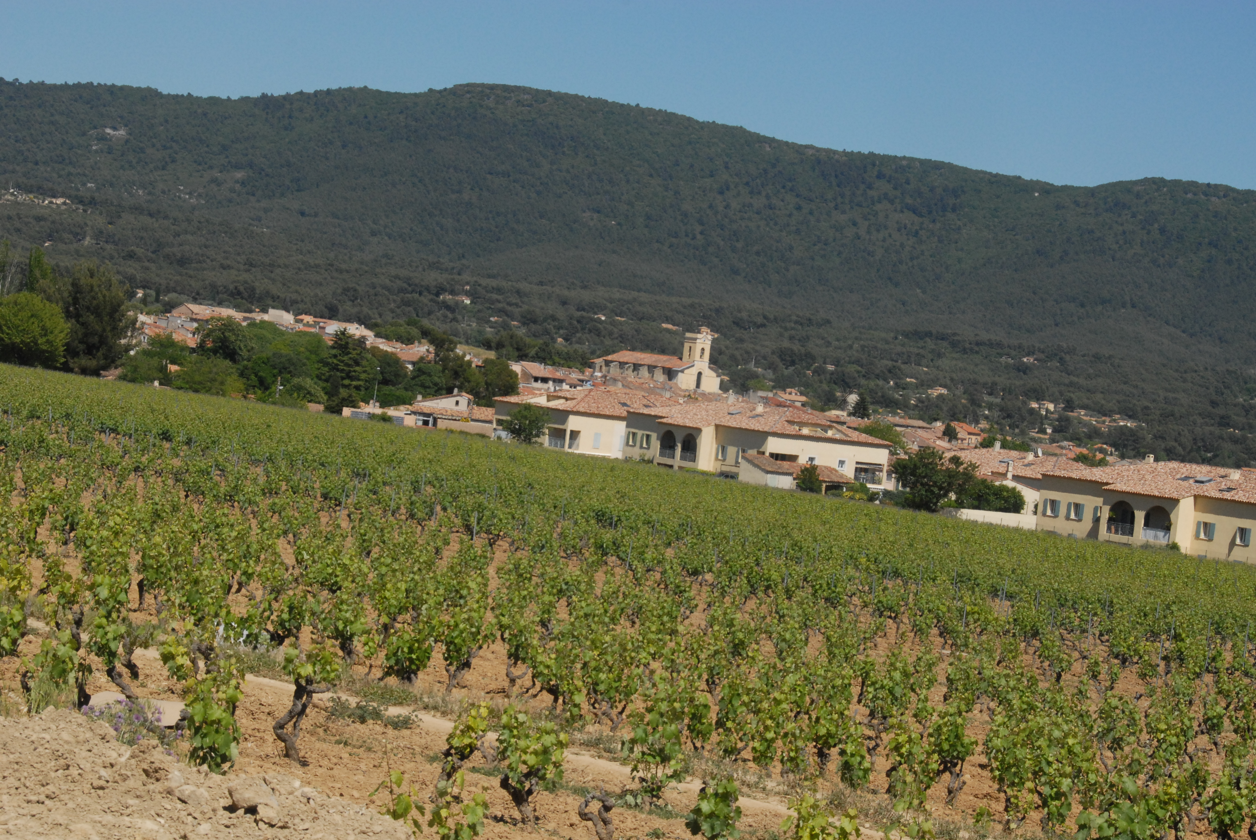

Bandol (June 10, 2012)
Method:

We would like to equilibrate reading and tasting. By reading is meant the art of deciphering and seeing the world at once as a landscape and a palimpsest. If the complexities of « reading » are compared to that of « reading » a map—do we find a narrative « thread » in a map? do we « see » toponyms floating in a space of the shaded relief designating mountains and hillsides ?—then oenology cannot be detached from geography and its adjunct science, topography. Hence oenography : we will read the world of wine on a cartographic palette. The sensations of what we taste become the elements of the space we fashion from the places we study.

I propose that we begin with France and its principal regions—the Bordelais, Burgundy, the Loire Valley, the Southwest (Languedoc), the Rhône Valley—before touching, time permitting, on some of the other regions in which great wines are made : Champagne (the Soissonnais), Franche-Comté, Alsace-Lorraine. We will apportion our study of these areas according to the wines made—white, red, and rosé—and their grapes—that include melon de Bourgogne, sauvignon blanc, chenin blanc, cabernet franc, chardonnay, fumé blanc, sémillon, cabernet sauvignon, merlot, petit verdot, viognier, pinot noir, grenache, mourvèdre, carignan, cinsault, malbec, syrah, pinot gris, and others.

We shall then study the other regions along similar taxonomic itineraries, including Italy (sangiovese, primitivo, negro d’amaro, tempranillo…) and Spain (jumilla, garnacha, tempranillo) in contrast with New World counterparts, be they in California, Oregon, Washington, the Finger Lakes, Long Island, North Carolina, Chile or Argentina One of the tasks we shall assign ourselves will be to read and taste, to take notes about what we sense, and to keep a diary and even, where it is wished, collect the labels of the wines we sample.

Bibliography:

It is copious, but so also are the sensory impressions we gain as we taste. We are purchasing some books for the Hicks House and then putting others on reserve for the sake of knowledge. Among others, in a plethora of titles (recommended: *):

Asimov, Eric. How to Love Wine: A Memoir and a Manifesto. (New York: Harper, 2012).
---. “The Pour” and “Wine School”, Wednesdays, New York Times “Food” Section.*
Bonné, Jon. The New Califorinia Wine (San Francisco: 10 Speed Press, 2013).
Dumay, Raymond. La Mort du vin (Paris: La Table Ronde, 1976).
Ferguson, Priscilla Parkhurst. Accounting for Taste : The Triumph of French Cuisine (Chicago : University of Chicago Press, 2005).
Gohorry, Jacques. Devis sur la vigne: vin et vendanges… (Paris: Vincent Sertenas, 1549).
Goldberg, Howard. New York Times Book of Wine (New York: Sterling & Epicure, 2012).
Johnson, Hugh. The Story of Wine (London : Mitchell Beazley, 2004).
---. The Wine Atlas of France (New York : Simon & Schuster, 1987).
---. How to Enjoy Wine (New York : Simon & Schuster, 1985).
---. Vintage : The Story of Wine (New York : Simon & Schuster, 1989).
Johnson, Hugh and Jancis Robinson. The World Atlas of Wine (New York : Mitchell Beazley, 2001).
Lichine, Alexis. The Wines of France (New York : Alfred A. Knopf, 1962)
Lynch, Kermit. Adventures on the Wine Route (New York : Farrar, Straus and Giroux, 1988).*
Martin, Neal. Pomerol. <pomerolbook.com>. [600 pp. @$80]
The Oxford Concise Wine Companion (Oxford : Oxford University Press, 2005).*
Read, Jan. The Wine & Food of Spain (Boston : Little & Brown, 1987).
Rowley, Anthony and Jean-Claude Ribaut, Le Vin: Une histoire de goût (Paris: Gallimard, 2003.
Serres, Olivier de. Le Théâtre d’agriculture et le mesnage des champs (Paris: Jamet Mettayer, 1600) [see Houghton copies]
Shand, P. Morton. A Book of French Wines (New York : Alfred A. Knopf, 1928)
---. Wine Today, and Wine Tomorrow (New York : Dutton, 1927).
---. A Book of Food (New York : Alfred A. Knopf, 1927).
Shuster, Michael. Essential Winetasting (London : Mitchell Beazley, 2000).
Smith, Clark. Postmodern Winemaking (Berkeley: U of California P, 2013).
Walker, Ray. The Road to Burgundy: The Unlikely Story of an American Making Wine and a New Life in France ([New York]: Gotham Books, 2013).

*highly recommended

Time and place

We would like to meet on alternating Tuesday evenings at 7:15-7:30 p.m. in the Junior Common Room. We shall bring our texts, glasses, bottles, notebooks, and the dictionaries of our wit. Through taste we shall turn the place into a space of our own. We will need ample supplies of water and bread to clear our palettes between tastings.

Requirements

Every student will keep a taster’s log of the wines sampled. Included, for the sake of information ought to be for each bottle the appellation, the year of the vintage, the genus of the grape or grapes; for the sake of oenography, included should be notes about savor: the bouquet, the palette, and the finish ; the general « impression » of the wine in the context of others of similar origin or style ; the contrast between a wine of a given grape grown on one continent and its counterpart on another. Along the way a grasp of geography—and, given the notion of terroir, of topography—will be needed, and thus students will be asked to draw or build an atlas of oenological maps. As in earlier vintages of the seminar, students may wish to do individual and/or focused presentations of chosen wines. We should like to open a web site on the Kirkland page where images, dialogue, and annotations can be registered.

Grading

Insofar as the class of 2015 cannot be offered for credit, good will and assiduity equal a good grade. We can use what we gain together from our community and what we gain together as matter that will recommend us cultivate our taste. Steady attendance and committed attention to the wines and to their origins are crucial for success in the class, and so also is participation: we all appreciate collective and convivial discussion that engages and moves about and around the wines and their savor.

Imagination and Image

Insofar as “geography is destiny” we would like to bring maps and local images to the class in order to have us gather a sense of the way that grapes figure in their landscapes. We will make use of topographical maps (fairly good ones are found in Jancis/Robinson, while others can be taken from web or, for those who will be in Paris, purchased at the Legrand wine store—one of the best in the city—at the Passage Vivienne, 2e arrondissement, adjacent to the Place de la Victoire). A new and changing field is found in viticultural cartography, especially in view of the consequence of global warming.

Further Thoughts

Since wine cannot be consumed without food, we will need to have a supply of bread and pitchers of water around the table. We might want to coordinate our tastings with cheeses, at least in respect to what we study of France, Spain, and Italy. Roland Barthes remarked (in Mythologies) that in France there exists a different cheese for every day of the year. It would be difficult to bring 365 cheeses to the table, but nonetheless we might want to coordinate regional cheeses and their composition (persillé, à pâte molle lavée, crottin de chèvre, fromage frais, rassis, bien affiné, etc.) with the wines we taste. Given the size and the desires of the class we ask members to contribute $35—as if it were an investment in books–to defray the costs of the weekly tastings.

At least two films can be included in the schedule: Mondovino (Jonathan Nossiter, 2004), about the globalization of wine; Sideways (Alexander Payne, 2004). We should like to schedule (but cannot yet promise) visits from savant oenophiles in the area.

Schedule

Week of February 3

Introduction. Etiquette and étiquette ; shape and contour of the bottle and the glass ; the label; fermentation ; aging ; signs of taste (tannins, oak, fruit); a poetics of description. The construction of a cave and a collection, with emphasis placed on focus. The wines of the Loire: whites contrasted: Muscadet (its grape the melon de Bourgogne), dry and crisp, softly acrid like mother-of-pearl; Vouvray and Cheverny (chenin blanc and sauvignon blanc, while further east chardonnay for Sancerre and Poully-Fumé. Two great and uncommon reds: Bourgeuil and Chinon based on cabernet franc:. The whites: Muscadet and Muscadet-sur-lie; Vouvray dry and Vouvray moelleux. Sancerre, “la craie”, to be contrasted with a softer Pouilly-Fumé. The Touraine, “le jardin de la France”, that harbors memories of Rabelais, Du Bellay, Ronsard and Balzac….

Read: Barthes, Mythologies, on wine, cheese, and milk; begin Lynch, Adventures…; read: Johnson/Robinson, 7-50; 116-23; read also: “The Wine Snob’s Dictionary” (handout).

<<<<February 11>>>> Visit of Eric Asimov to the Harvard Wine Society (Kirkland JCR). A lotteried event.

Week of February 17

Valentine’s Day means red wine: heading south and west, we’ll sample the noble vintages of the Bordelais: Bordeaux and the two shores of the Gironde: Graves, Pessac-Leognan, Saint-Emilion on the one side and on the other, Médoc, Saint-Julien, Pauillac, Margaux…. Mention of the great vintages in the hope that one day we will sample them: Léoville-Las-Cases, Palmer, Margaux, Haut-Brion, Calon-Ségur, Mouton-Rothschild, Lafitte-Rothchild, and the lesser but great growths: Beychevelle, Meyney, and a variety of crus bourgeois. Cabernet sauvignon, merlot, cabernet franc, petit verdot, sauvignon blanc. Selection will be made according to the pocketbook, but will include, surely: Saint-Emilion, Lussac-Saint-Emilion, Côtes du Bourg, Bordeaux Supérieur, Médoc. A geography is vital for understanding this area of enormous and unsurpassed production.

Read: Lichine, on Bordeaux; Johnson/Robinson, 82-111.

Week of March 3

Either the wines of the Roussillon that include Cahors, Bergerac, the Pyrénées, Minervois, Saint-Chinian, etc., and regions formerly given to bulk vin de table that are now making extraordinary inroads with a variety of grapes: Mourvèdre, Carignan, Malbec, Viognier, and blends of Syrah, Grenache and Merlot. An area where prices remain reasonable, or…

Crossing the Rhône sur le pont d’Avignon: echoes of Châteauneuf-du-Pape, the regal red; a sampling of the great reds along the Rhône: Sablet, Gigondas, Vinsobres. And the minor “quaffers”: the côtes du Lubéron and the côtes du Ventoux. Introduction to the general appellation “Côtes du Rhône”: the varietal grapes that include Grenache, Cinsault, Mourvèdre, Syrah, Carignan, Viognier. If possible, a glance at two great wines of the region: Baumes-de-Venise (amber dessert wine) and Tavel, the rosé of rosés. The Rhône, being a very complex and variegated region, may indeed demand two sessions.

Read: Johnson/Robinson, 134-37; 144-46.

Week of March 31

Moving north along la route du soleil and the River Rhône: upper Rhônes, the “big” wines bearing the names Cornas, Hermitage, Crozes-Hermitage, Côte-Rotie, Saint-Joseph. Reflections on the syrah, the grape that offsets the Grenache found about and below the “45th Parallel”. Some great and reasonable chardonnays: Mâcon, Saint-Véran. A geography of the “seven hills” of the Beaujolais: Moulin-à-Vent, Brouilly, Juliénas, Morgon. “Beaujolais” and “Beaujolais-Villages”; the gamay grape. The myth of “Beaujolais nouveau”.

Burgundy, a noble color and a noble name. Introduction to the appellations along the Côte d’or (and the Côtes de nuits). From Dijon: from Pommard to Fixin and Gevry-Chambertin to Volnay, Clos-Vougeot, and other acreage down to Beaune. For lack of spondulicks, an appreciation of local vintages: “Côtes de Beaune” and “Arrière-côtes de Beaune”; a sampling of the appellation “Bourgogne” and “pinot noir”; a Dijon tradition: “Bourgogne aligoté” at the basis of the “Kir” (named after the canon Kir). The greatest of grapes in the greatest of places: pinot noir on the Côte d’or.

Read: Johnson/Robinson, 54-74; 129-33.

********
*****
***
**
*

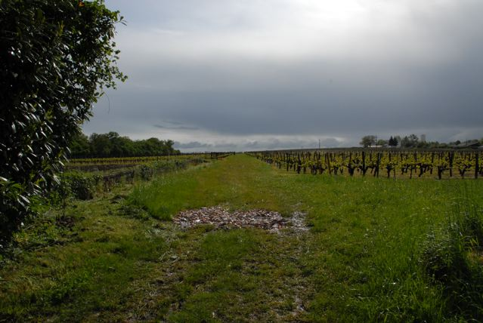

Château de Montaigne (Bergerac) May 1, 2008

Week of April 7

Introduction to the wines of Italy: to the north, the Piemontese (especially for the white, such as the pinot grigio, the grey pinot whose counterparts are in Alsace and now, tellingly, in Oregon and Washington. Attention drawn to the sangiovese that marks the reds of Tuscany. Some essays: Dolcetto versus Nebbiolo, Barbaresco and Chianti. We dream of sampling Brunello or an Amarone, the great wines of the north and center). We shall sample the nebbiolo grape and the negro amaro of Puglia and Calabria. The wines of southern Italy: primitivo, the unique grape of Puglia and Calabria that migrates to northern California in the name of zinfandel. The wines of Molise in contrast and comparison. The great and deep red wines of Sicily (see Asimov, NYT, January, for results of recent tasting that leans toward blended reds).

Read: Johnson/Robinson, 153-85.

Week of April 21

The New World: Californian reds: cabernet sauvignon, zinfandel, and pinot noir; the pinot noir of Oregon and Washington. Sonoma and Napa Valleys compared (zinfandel in the former and the sauvignon in the latter). A sampling of young and old red wines from various vines, young and old. Comparison of Italian primitivo (week of April 9) to California zinfandels (with special attention to “Amador County”). The New World: Argentina and Chile. The malbec and sauvignon grapes. Transplantation and new tastes. A comparison and contrast of the “original” malbec in the region of Cahors and around Carcassonne (in southern France) to its new world counterpart. If possible, some comparative tasting of the malbec rosé with a southern French counterpart from Tavel or, say, La Ciotat (Bandol). Study of the industrial or “globalized”, highly “oaked” wines (produced for a world market) and those that carry a European signature. Towards a new definition of Latin American terroir.

Week of April 28

Weather permitting, an outdoor tasting of summer wines: Rosé from Provence—notably, Tavel--and Touraine--Anjou, plus a moment for suggestions and comparisons. Presentations, conclusions, examinations and evaluations. We should like to have a “virtual” final exam in the form of a review of grapes and regions along with a blind tasting of about a half-dozen wines, some having been sampled in the earlier weeks, others—for the sake of testing our lexicon—possibly unfamiliar to our palettes.

